|  |
| --- |
| US Department of Labor  office of labor-management standards |
| CBA Registration & Disclosure |
| Functional Requirements |
| Release v1.0 |
|  |

**Revision History**

|  |  |  |  |
| --- | --- | --- | --- |
| **Date** | **Revision** | **Description** | **Author** |
| **09/08/2020** | **1.0** | **Initial Draft** | **Bineeta Adityan** |
|  |  |  |  |
|  |  |  |  |

**Contents**

1. Project Description 1

2. Purpose 1

2.1. Definitions, Acronyms, Abbreviations 1

2.2. References 1

3. FUNCTIONAL REQUIREMENTS 1

3.1. Login 1

3.2. Default Page 2

3.3. Employer and CBA Registration 2

3.3.1. Navigation 2

3.3.2. Employer 2

3.3.2.1. Employer Listing Page 3

3.3.2.1.1. Sort and Column filter 3

3.3.2.1.2. Field Level Requirements 4

3.3.2.2. Add New Employer (manually) 6

3.3.2.3. Import Process 7

3.3.2.3.1. Import data requirements 8

3.3.2.3.2. Import Data file 8

3.3.3. F7 Letter 9

3.3.3.1.1. Signature 9

3.3.3.2. F7 Letter Editor 9

3.3.3.3. Send F7 Notification 9

3.3.3.3.1. Email F7 letters 10

3.3.3.3.2. Sending F7 Letters when CBA expired 10

3.3.3.3.3. Print F7 letters 10

3.3.3.4. Other Functions on the Employer Page 10

3.3.3.4.1. Mark as Mail Returned 10

3.3.3.4.2. Export 10

3.3.3.5. Edit Employer 11

3.3.4. CBA 11

3.3.4.1. Review and Publish Page 13

3.3.4.2. CBA Listing Page 14

3.3.4.3. OPDR Display 15

3.3.4.4. Renewing an Expired CBA 15

3.3.4.5. Un-publish or republish a CBA 16

3.3.4.6. Export 16

3.3.5. Reports 16

3.3.5.1. Statistics Report 16

3.3.5.1.1. Statistics Report – Export 17

3.3.5.2. Counts By Month – Report 17

3.3.5.2.1. Counts By Month Report– Export 18

4. Requirements Revisions History 18

# Project Description

The OLMS Content Management System (OCOMS) is the Office of Labor-Management Standards’ (OLMS) new web-based system for registering and disclosing the following Web contents:

• FOIA Letters

• OLMS Weekly Reports

• CBA

# Purpose

The purpose of this project is to create a tool to register and disclose the CBA records.

# Definitions, Acronyms, Abbreviations

The following is a list of commonly used acronyms used throughout this document:

| Term | Definition |
| --- | --- |
| CBA | Collective Bargaining Agreements |
| OCOMS | OLMS Content Management System |
| DOL | Department of Labor |
| OLMS | Office of Labor-Management Standards |
| FOIA | Freedom of Information Act |
| FMCS | Federal Mediation and Conciliation Service |

# References

* ESAKDatabaseOLMS.mdb
* OLMS_CBASearchTool.laccdb
* CBA Instructional Guide
* F7 Notice Spreadsheet

# FUNCTIONAL REQUIREMENTS

The Initial Release of OCOMS will include only the CBA registration sections. This document covers the functional Requirements for registering and disclosing the Collective Bargaining Agreements (CBA) submitted by various employers. The application will be available only to the internal OLMS users

# Login

The OCOMS system will display the login page. A mock-up listed below:

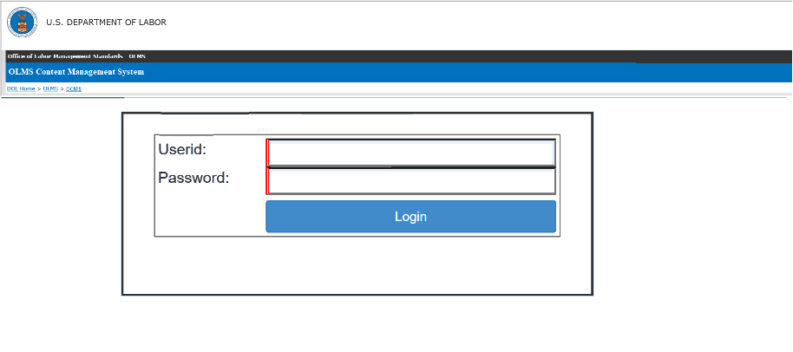

# Default Page

Upon a successful login, the user will be navigated to the following page:

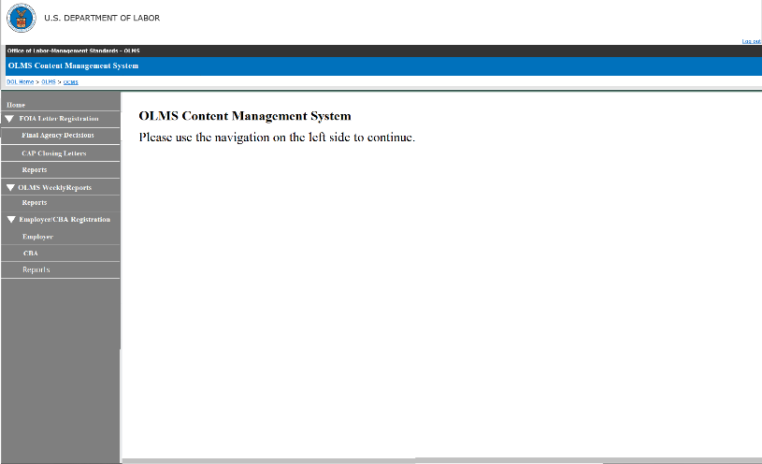

# Employer and CBA Registration

This section will have the following pages:

* Employer
* CBA
* Reports

# Navigation

The system has the page navigation on the left side. The **Employer/CBA Registration** section will have the following pages added.

* Employer
* CBA
* Reports

# Employer

Clicking the Employer link will open the Employer listing page. A mock-up design for the Employer page is displayed below.

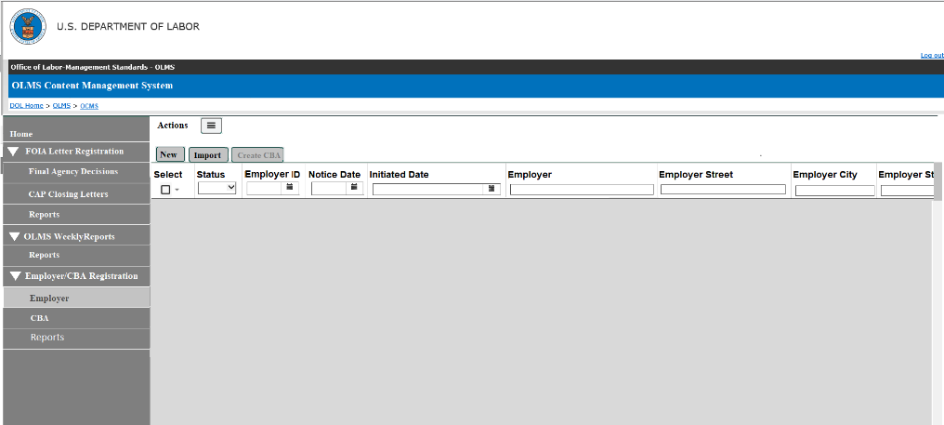

# Employer Listing Page

The Employer data will be listed in the Employer listing page. Mock-up for the listing screen is listed below:

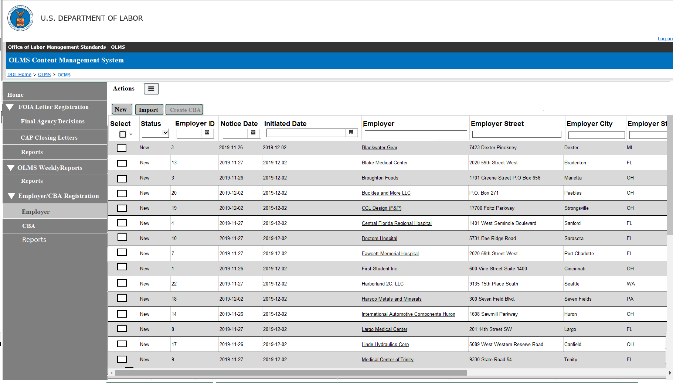

Sample Data listing



# Sort and Column filter

Each column will have Sort, and Column filter added. The user should be able to use one or more column filters. Additional column filter requirements added to the field level requirements.

# Field Level Requirements

**Status –**The status of each employer will be listed in this field. The following are the different statuses. The column filter for this field will be a drop-down list to pick one list status.

* **New –** Newly created employers will have this status.
* **F7 Notice Sent –** The employers who have emailed the F7 Notice will have this status.
* **F7 Letter Printed –** The employers who have the F7 letters
* **CBA Received –** The employers who have the CBA registered and published on OPDR
* **Mail Returned –** The user will set this status if the mail is returned (probably the mail address is wrong).

**Employer ID** – This column will list the unique identifier for each employer. The column filter will allow the user to search for any particular Employer ID.

**Notice Date** – This column will list Notice Date. The format will be YYYY-MM-DD. This field will have a date range column filter.

**Initiated Date** – This column will list the Initiated Date. The format will be YYYY-MM-DD. This field will have a date range column filter.

**Employer Name** - This column will list the name of the employers. More than one employer's name may be entered in this field. The system should list the list multiple names with a separator (slash (/), comma (,), ampersand (&)). The user should be able to use a full or partial name to filter the list.

**Employer Street** – This column will list the employer's street address. The user should be able to use a full or partial address to filter the list.

**Employer City** – This column will list the city. The user should be able to use a full or partial city name to filter the list.

**Employer State** – This column will list the state. The column filter sbould be a dropdown list to pick a state.

**Employer ZIP** - This column will list the Zip Code.

**Employer Representative** – This column will list the name of the employer’s representative’s first and last name. The user should be able to use a full or partial name to filter the list.

**Employer Rep Phone** – This column will list the phone number.

**Employer Rep Title** – This column will list the title. The user should be able to use a full or partial title to filter the list.

**Employer Rep Email** – This column will list the email address. The user should be able to use a full or partial email to filter the list.

**Union Name** – This column will list the union name. The system should list the list of multiple unions with a separator (slash (/), comma (,), ampersand (&)). The user should be able to use a full or partial union name to filter the list.

**Union Abbreviation** – This column will list the union abbreviation. The system should list the list multiple Union’s abbreviations with a separator (slash (/), comma (,), ampersand (&)). The user should be able to use full or partial union abbreviations to filter the list.

**Union Designation** – This column will list the designation. The system should list the list multiple Union’s designations with a separator (slash (/), comma (,), ampersand (&)). The user should be able to use full or partial union designations to filter the list.

**Union Local Number** – This column will list the Union local identifier. The system should list the list multiple Union’s local number with a separator (slash (/), comma (,), ampersand (&)). The user should be able to use full or partial Union local number to filter the list.

**Union Street** - This column will list the Union’s street address. The user should be able to use the full or partial address to filter the list

**Union City** - This column will list the city. The user should be able to use the full or partial city to filter the list.

**Union State** - This column will list the state. The column filter should be a dropdown list to pick a state.

**Union ZIP** - This column will list the Zip Code.

**Union Representative** - This column will list the Union representative’s first and last name. The user should be able to use a full or partial name to filter the list

**Union Rep Phone** - This column will list the phone number.

**Union Rep Title** - This column will list the title. The user should be able to use a full or partial title to filter the list.

**Union Rep Email** - This column will list the email address. The user should be able to use a full or partial email to filter the list.

**Affected Location City** - This column will list the location city. The user should be able to use a full or partial city name to filter the list.

**Affected Location State** - This column will list the state. The column filter should be a dropdown list to pick a state.

**Affected Location ZIP** - This column will list the Zip Code.

**Expiration Date** - This column will list the Expiration Date. The format will be YYYY-MM-DD. This field will have a date range column filter.

**Industry** – This column will list the Industry name. The user should be able to use a full or partial name to filter the list.

**Bargaining Unit Size** - This column will list the unit size. The user should be able to enter a minimum and maximum number to filter the list.

**Establishment Size** - This column will list the Establishment size. The user should be able to enter a minimum and maximum number to filter the list.

**Notice Submitted By** – This column will list the source for the F7 notice. The user should be able to enter full or partial text to filter the list..

**Category** – This column will list the category of each employer. The user should be able to enter full or partial text to filter the list.

**Healthcare Related** – This column will list Y and N. The column filter should be a drop-down list.

**Created Date** – This column will list the date in which the employer was created. The format will be YYYY-MM-DD. This field will have a date range column filter.

**Email Sent Date** – This column will list the date in which the F7 letter is emailed to the employer. The format will be YYYY-MM-DD. This field will have a date range column filter.

**Letter Print Date** – This column will list the date in which the F7 letter is printed. The format will be YYYY-MM-DD. This field will have a date range column filter.

# Add New Employer (manually)

The system should provide a function to create an employer record manually.

The following fields should be listed on this editor.

**Employer ID** – Initially, this field will be blank and will be read-only. Upon save, the system will generate a unique identifier for each employer.

**Notice Date** – This will be a date field. The format will be YYYY-MM-DD.

**Initiated Date** – This will be a date field. The format will be YYYY-MM-DD.

**Employer Name** - This will be a text field to enter the employer's name. More than one employer's name may be entered in this field. The system should allow entering each employer with a separator (slash (/), comma (,), ampersand (&)).

**Employer Street** – This will be the address field to enter the employer's street address.

**Employer City** – This will be the text field to enter the city.

**Employer State** – This will be a drop-down field to select the state.

**Employer ZIP** - This will be a numeric field in 5 (xxxxx) or 5+4 format (xxxxx-xxxx)

**Employer Representative** – This will be a text field to enter the employer's representative's first and last name.

**Employer Rep Phone** – This will be a field to enter the phone number.

**Employer Rep Title** – This will be a text field to enter the title.

**Employer Rep Email** – This will be a field to enter the email address.

**Include Employer Rep's Email on the F7 Notice** – This will be a check-box field. Checking this box will add the Employer Representative's email address will be included in the F7 Email.

**Union Name** – This will be a text field to enter the union name. More than one union may be entered in this field. The system should allow entering each union with a separator (slash (/), comma (,), ampersand (&)).

**Union Abbreviation** – This will be the text field to enter the union abbreviation. The system should allow entering each Union abbreviation with a separator (slash (/), comma (,), ampersand (&)).

**Union Designation** – This will be a text field to enter the designation. The system should allow entering each union designation with a separator (slash (/), comma (,), ampersand (&)).

**Union Local Number** – This will be a text field to enter the Union local identifier. The system should allow entering each Union local number with a separator (slash (/), comma (,), ampersand (&)).

**Union Street** - This will be the address field to enter the Union’s street address

**Union City** - This will be the text field to the city.

**Union State** - This will be a drop-down field to select the state.

**Union ZIP** - This will be a numeric field in 5 (xxxxx) or 5+4 format (xxxxx-xxxx).

**Union Representative** - This will be a text field to enter the Union representative’s first and last name.

**Union Rep Phone** - This will be a field to enter the phone number.

**Union Rep Title** - This will be a text field to enter the title.

**Union Rep Email** - This will be a field to enter the email address.

**Include Union Rep’s Email on the F7 Notice** – This will be a check-box field. Checking this box will add the Union Representative’s email address will be included in the F7 Email.

**Affected Location City** - This will be the text field to the city.

**Affected Location State** - This will be a drop-down field to select the state. The user should be allowed to enter multiple locations with a slash separator.

**Affected Location ZIP** - This will be a field in 5 (xxxxx) or 5+4 format (xxxxx-xxxx).

**Expiration Date** - This will be a date field. The format will be YYYY-MM-DD.

**Industry** – This will be a text field to enter the name of the industry

**Bargaining Unit Size** - This will be an integer field to enter the unit size.

**Establishment Size** - This will be an integer field to enter the unit size.

**Notice Submitted By** - This will be a text field.

**Category** - This will be a text field

**Healthcare Related** – This will be a Y and N field

# Import Process

The employer data set will get inserted by the import process. OLMS get a CSV file listing the employers every month from the Federal Mediation and Conciliation Service (FMCS) agency. The user will make the following modifications to the file to import the data.

* Remove NAICS code from the spreadsheet. It is not the code that OLMS discloses. The NAICS code will be added on the CBA registration page once OLMS receives the CBA agreement file.
* Split the union details into the following data fields and get as much information for these fields. The union abbreviation, designation, or local number can be blank in the spreadsheet if they do not have this information.
* Union Name
* Union Abbreviation
* Union Designation
* Union Local Number

# Import data requirements

* Every successfully imported employer record will get a unique identifier, Employer ID.
* The status of each record will set to **New.**
* The import process will have a duplicate check to identify any duplicate records in the file.
  + The Duplicate check will use the combination of the following data elements in the CSV.
  + Employer, employer address, employer representative, union, union address, union representative, and the industry
    - The data has to be an exact match to mark it as duplicate
  + If the same data combination is already in the database (previously created), the data should not be downloaded.
    - Display the data for the user to review
    - The review list should have the following options
      * Remove from the import (the user will choose this option if the data is duplicate)
      * Proceed and import the data (the user will choose this option if the data is not duplicate)

# Import Data file

The import file should have the following data fields

**Notice Date**

**Initiated Date**

**Employer Name**

**Employer Street**

**Employer City**

**Employer State**

**Employer ZIP**

**Employer Representative**

**Employer Rep Phone**

**Employer Rep Title**

**Employer Rep Email**

**Union Name**

**Union Abbreviation**

**Union Designation**

**Union Local Number**

**Union Street**

**Union City**

**Union State**

**Union ZIP**

**Union Representative**

**Union Rep Phone**

**Union Rep Title**

**Union Rep Email**

**Affected Location City**

**Affected Location State**

**Affected Location ZIP**

**Expiration Date**

**Industry**

**Bargaining Unit Size**

**Establishment Size**

**Notice Submitted By**

**Category** -

**Healthcare Related**

# F7 Letter

The user should be able to select one or more employers to send the F7 letter.

The system will print F7 notice for each employer selected. The letter will have employer ID, employer name, address and the expiration date for each employer populated.

# Signature

The system should have an option to select a user from a drop-down to add the letter's signature.

# F7 Letter Editor

The system will provide a formatting capability to edit the text listed in the letter.

* The editor should have text formatting capability
* The editor should have an option to preview the letter.

# Send F7 Notification

The system will support the following notification formats.

# Email F7 letters

The following requirements appled to the **Email F7 letters** function

* The user should be able to select one or more employers to print the F7 letter.
* The user should be able to print the F7 letter for each employer selected.
  + The letter should have the Employer ID, Employer Name, Address, and the Expiration date printed.
* The status of these records will be changed to the **F7 letter printed**.
* The system will also track the **letter print date**.
* The system will track both **Email Sent date** and **letter printed date** separately for those who have **Email** and **mail** sent.
* The user should be able to resend the letter to the employers.
  + When resending the letter, the system should track the **letter sent date**.

# Sending F7 Letters when CBA expired

The user should be able to select any employer on the list to resend the letter.

# Print F7 letters

The following requirements applied to the **Print F7 letters** function:

* The user should be able to select one or more employers to print the F7 letter.
* The user should be able to print the F7 letter for each employer selected.
  + The letter should have the Employer ID, Employer Name, Address and the Expiration date printed.
* The status of these records will be changed to the **F7 letter printed**.
* The system will also track the **letter print date**.
* The system will track both **Email Sent date** and **letter printed date** separately for those who have **Email and Mail** sent.
* The user should be able to resend the mail to the employers.
  + When resending the letter, the system should track the **letter printed date**.

# Other Functions on the Employer Page

The employer page should have the following functions added:

# Mark as Mail Returned

The following requirements applied to the **Mark As Mail Returned** function:

* The user should be able to select one or more employers and **Mark As Mail Returned** option.
* The status for those records will be **Mail Returned.**

# Export

The following requirements appled to the **Export** function:

* The system should provide the following Export options
  + **Export All**
  + **Export Selected**
  + **Export as Filtered**
* The export file should list all data fields listed on te Employer page.

# Edit Employer

The user should be able to open an employer record to modify the data associated.

* From the Employer listing screen, the user should click on the employer name to open the editor.
* The editor will list all the all fields listed in **section 3.3.2.2.**
* In addition to those fields, the editor will list the following fields.
  + **Email Sent Date** – This will be a read-only field. This field will display the date in which the F7 letter is emailed to the employer. The field will be blank if no emails are sent
  + **Letter Print Date** - This will be a read-only field. This field will display the date in which the F7 letter is emailed to the employer. The field will be blank if no emails are sent.
  + **Mark as Mail Returned** – this is a check box field.
  + **Created Date** - This will be a read-only field. This field will display the date in which the employer record was created
* A **Delete** button should be provided to delete the employer selected.

# CBA

The following requirements applied to this editor.

* Upon receiveing a CBA agreement from the employer, the user will select the employer record from the Employer listing screen and click **Create CBA** button to create a CBA record.
* An agreement maybe with multiple employers, so the user should be allowed to select one or more employer from the list.
* The selected employer’s and union’s information will be listed on the CBA editor.

The following fields will be listed on this editor.

**Employer ID** – The Employer ID will be populated by the system and will not be editable.

* If more than one employer is selected, the system will list all employer’s Employer ID

**CBA ID** – The system will generate this ID upon save.

**Date CBA Received** – This will be a date field. The user will enter (or select from the calendar pick) this date.

**Employer Name** - The employer's name will be populated by the system and will be editable. The system will also provide a search feature to find an existing employer if the data needs to be replaced.

* If more than one employer is selected, the system will list all employer’s names on the page.
* **Add Employer** – Clicking this button will open a search window to search and pick an employer to the CBA selected. The selected Employer’s ID and information will be listed on the screen.

**Location** – This will be a text field. The user will enter data in this field.

**Union Name** - The data will be populated by the system and will be editable. The system will also provide a search feature to find an existing union if the data needs to be replaced.

* If more than one employer is selected, the unions associated will all employers will be listed on this page.
* **Add Union –** Clicking this button will open a search window to search and pick a union. The selected union will be listed on the screen.
  + When adding unions, the system will populate the information on all other union-related fields.

**Local Number** - The data will be populated by the system and will be editable.

* If more than one employer is selected, the local number for the unions associated will all employers will be listed on this page.

**Union Abbreviation** – The data will be populated by the system and will be editable.

* If more than one employer is selected, the abbreviation for the unions associated will all employers will be listed on this page.

**Union Designation** – The data will be populated by the system and will be editable.

* If more than one employer is selected, the designation for the unions associated will all employers will be listed on this page.

**NAICS # -**  This will be a numeric field.

**Number of Employees –** This will be a numeric field to enter the number of employees.

**Expiration Date** - This will be a date field. The user will enter (or select from the calendar pick) this date.

**Number of Pages** - This will be a numeric field to enter the number of pages in the agreement document.

**Agreement** **–** This will be a drop-down field listing the values, **Public**, **Private** and **confidential**.

**Incomplete** – This is a checkbox field. The user will use this to track incomplete CBA.

**Do Not Publish** – This will be a checkbox field. The following requirements are applicable to this field.

* For the **Confidential** type, this box will be **checked** **automatically**
* Checking this checkbox will stop publishing the CBA on the OPDR page.
* The user will check this checkbox will stop publishing any CBA on the OPDR page

**Button to browse and upload the agreement file -**  The user will click this button to browse for the agreement saved in the user’s computer to attach it.

**Comment box** – This is a text field to enter any additional information.

**Save** – Clicking this button will save the data entered.

**Cancel** – Clicking this button to close the editor.

**Review and Publish** – Requirements for this button are listed below:

* Upon entering the data set and save the page, the **Review and Publish** button will be enabled.
* This button will get **enabled** only for the **Private** and **Public** CBAs.
* This button will **not get enabled** of the **Do Not Publish** button is checked.
* Clicking the **Review and Publish** button will open a new page displaying the data entered.

# Review and Publish Page

This will be a preview page before publishing the data on the OPDR page. The following fields will be listed on this page. All fields will be **read-only** on this page.

**Employer Name** – This field will list the name of the employer. If multiple employers are associated, each employer’s name will be listed with a slash separator.

**View** – This will provide a link to the agreement attached. The user should be able to click and open the agreement.

**Location** – This field will list the location entered.

**Union -**  This field will list the union name. Multiple unions will be listed with slash separator.

**Local Number -** This field will list the union's local number. Multiple union's local numbers will be listed with slash separator.

**Union Abbreviation -** This field will list the union abbreviation. multiple union abbreviations will be listed with slash separators.

**Union Designation -** This field will list the union designation. Multiple union designation will be listed with slash separator.

**Expiration Date –** This field will list the Expiration Date entered.

**NAICS -** This field will list the NAICS code entered.

**#Wrkrs -** This field will list the number of workers entered.

**# Pages -** This field will list the number of pages entered.

**Agreement -** This field will list the agreement selected.

**Edit –** Clicking this button, the user should be able to return to the editor for any additional changes**.**

**Cancel –** Clicking this button to close the preview editor

**Publish –** The following requirements applied to this editor

* Clicking this button will instantly publish the CBA data on this page's OLMS disclosure page (OPDR).
* On the Employer page, the status will change to **CBA Received**.

# CBA Listing Page

The following requirements are applied to the CBA Listing Page.

* The page will list all registered CBAs.
* The following fields will be listed on this list screen
* The page should have column filters available on all the columns listed.

**CBA ID** – This column will list the CBA ID

**Employer ID** – This column will list the Employer ID. If more than one employer is associated with a CBA, this field will list each employer ID with a slash separator.

**View** - This column will list the link to the CBA agreement document saved in the user’s computer to attach it

**Date CBA Received** – This column will list the date CBA received.

**Employer Name** - This column will list the employer. If more than one employer is associated with a CBA, this field will list each employer’s name with a slash separator.

**Location** – This column will list the location.

**Union Name** - This column will list the name of the union associated with the CBA. If more than one union associated with a CBA, this field will list each union’s name with a slash separator.

**Local Number** - This column will list the local number of the union associated with the CBA. If more than one union associated with a CBA, this field will list each union’s local number with a slash separator.

**Union Abbreviation** – This column will list the union abbreviation for the union associated with the CBA. If more than one union associated with a CBA, this field will list each union’s abbreviation with a slash separator.

**Union Designation** – This column will list the designation of the union associated with the CBA. If more than one union associated with a CBA, this field will list each union’s designation with a slash separator.

**NAICS # -**  This column will list the NAICS code associated with the CBA.

**Number of Employees –** This column will list the number of employees.

**Expiration Date** - This column will list the expiration date.

**Number of Pages** - This column will list the number of pages in the agreement document.

**Agreement** **–** This column will list the Agrement type of the CBA. ( **Public**, **Private** and **confidential**.)

**Incomplete** – This column will list the Y of the checkbox is checked. If not checked the field will list N.

**Do Not Publish** – This column will list the Y of the checkbox is checked. If not checked the field will list N.

# OPDR Display

The following requirements applied to OPDR CBA search page.

* A new page will be added to the OPDR Page
* All fields listed on the **Review and Publish** page will be listed on this new page.
* The page should have a filter option to filter **Public**, **Private** or **Both**
  + Selecting the **Private** option should list only Private CBAs.
  + Selecting the **Public** option should list only Public CBAs,
  + Selecting the **Both** option should list both Private and Public CBAs.
* The data format should be the same as the **Review and Publish** page.

# Renewing an Expired CBA

When the employer sends the renewed CBA, the user should be able to select the employer from the Employer page and register the new CBA. The following requirements are applied for renewing the CBA.

* Registering reviewed CBA will generate a new CBA ID
* The registration requirements will be the same as listed in 3.3.4 , 3.3.4.1
* OPDR will display both expire and renewed CBAs.

# Un-publish or republish a CBA

The user should be able to edit a CBA after it is published on the OPDR page.

* The user should be able to modify the data for any published CBA and republish it at any time
* A published CBA can be removed from the OPDR page by checking the check-box **Do Not Publish**
  + Selecting this check-box and saving should immediately remove the CBA from the OPDR page.

# Export

The system should provide the following Export options

* Export All
* Export Selected
* Export as Filtered

# Reports

The Report tab will have the following report pages listed.

* Statistics
* Counts By Month

# Statistics Report

The statistics page will list the counts of each CBA type registered during the time frame selected. The following types of CBAs and their counts based on the date range that the user selected should be listed.

* **Private CBAs** – The count of the CBAs with agreement type selected as Private
* **Public CBAs** - The count of the CBAs with agreement type selected as Public
* **Confidential CBAs** - The count of the CBAs with agreement type selected as Confidentials
* **Incomplete CBAs** - The count of the CBAs marked as incomplete
* **Email Sent** - The count of the F7 emails sent to the employers
* **Mail Returned** - The count of Employers that have **the Mail Returned** flag checked.
* **Duplicate CBA counts** – The count of duplicate CBAs. The Duplicate check will use the combination of the following data elements.
  + Employer, Location, union name, Union abbreviation, Union Designation, Expiration date, NAICS code, and Agreement.
* **Total counts**

# Statistics Report – Export

The user will be able to export the data corresponding to each count to an Excel spreadsheet.

The export files for the Private CBAs, Public CBAs, Confidential CBAs, Incomplete CBAs and Duplicate CBA counts will list all the following data fields.,

* Employer
* Location
* Union
* Local
* Expiration Date
* NAICS
* #Wrkrs
* Type

The export files for the Email Sent, and Mail Returned will list all the following data fields.

* Employer Name
* Employer Street
* Employer City
* Employer State
* Employer ZIP
* Employer Representative
* Employer Rep Phone
* Employer Rep Email

# Counts By Month – Report

The Counts By Month Report will provide a monthly registration counts of each CBA type. Based on the Begin and End Date entered, the page lists the data by month and the total count.

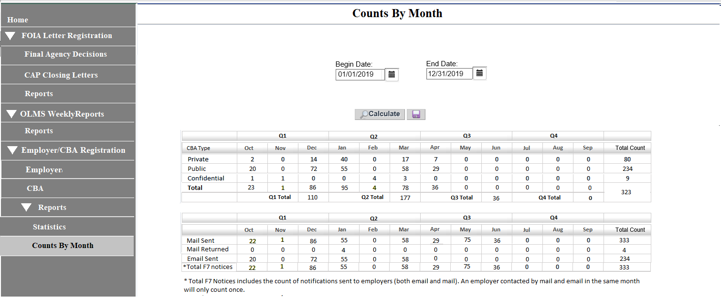

# Counts By Month Report– Export

The user will be able to export this page to an Excel spreadsheet.

# Requirements Revisions History

Meeting minutes for the review meetings are listed below:

| **Date** | **Stakeholders Involved** | **Meeting Minutes** | **Comments** |
| --- | --- | --- | --- |
| **06/18/2020** | Andrew Auerbach  Terry Thomas  Andrew Davis  James Haskins  Avieon Morgan |  |  |
| **07/13/2020** | James Haskins  Avieon Morgan  Henry Kalinowski  Jomica Becknell |  |  |
| **08/11/2020** | Andrew Auerbach  Andrew Davis  Terry Thomas  James Haskins  Avieon Morgan  Michael Delaney |  |  |